**Assignment -3**

Digital Marketing

|  |  |
| --- | --- |
| Student Name | Kali Sangareshwari M |
| Student Roll Number | 20URCS019 |
| NM ID | 2CACCF0CD5ECD7581324C8C06D826450 |
| College Name | AAA College of Engineering and Technology |

**QUESTION:**

**Create and design a social media advertisement poster using canva.**

**SOCIAL MEDIA ADVERTISEMENT POSTER USING CANVA:**

**Poster link:** <https://www.canva.com/design/DAFynXp9fwE/aX2IvCzLtdOeRCJCl79_nQ/edit?utm_content=DAFynXp9fwE&utm_campaign=designshare&utm_medium=link2&utm_source=sharebutton>

**Poster Title: Royal Wrists**

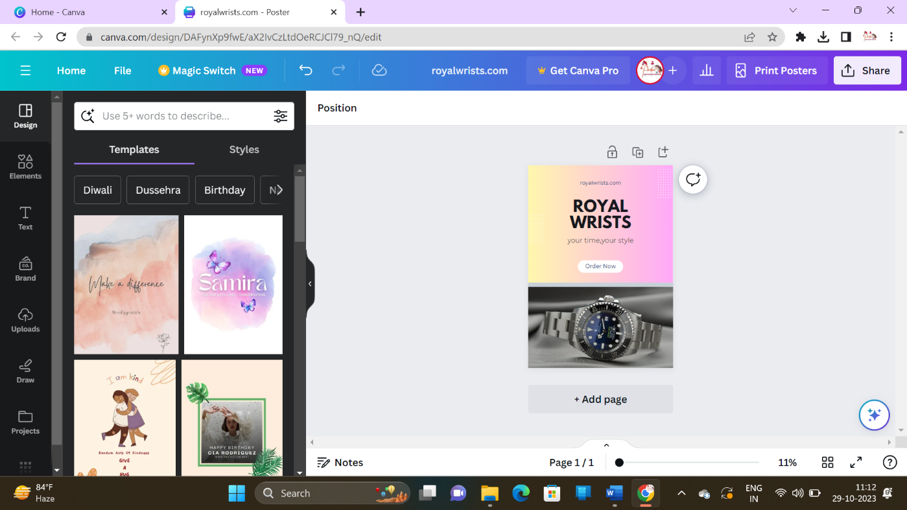

**Poster:**

